**TABLE OF CONTENTS**

|  |  |  |  |
| --- | --- | --- | --- |
| **S.no** | **Title** | **Page no** | |
| 1 | Introduction | | 6 |
| 2 | Methodology | | 7 |
| 3 | Source Code | | 11 |
| 4 | Result and Discussion | | 13 |
| 5 | Conclusion | | 13 |
| 6 | Future Scope | | 13 |
| 7 | References | | 14 |

# Introduction

Business owners and managers make use of modern data-gathering techniques to optimize retail delivery of products to the customer base. Forecasting in retail involves utilizing existing data to predict future events and, more specifically, consumer behavior. Existing data and market research varies by the types of products a retailer sells, but the basic means of forecasting in retail follows similar patterns, even across different product lines.

Retail forecasting methods anticipate the future purchasing actions of consumers by evaluating past revenue and consumer behavior over the previous months or year to discern patterns and develop forecasts for the upcoming months. Data is adjusted for seasonal trends, and then a plan for ordering and stocking products may follow the analysis. After fulfillment of current and forthcoming customer purchases and orders, an assessment of the results is compared with previous forecasts, and the entire procedure is repeated.

In retail management, forecasting serves to predict and meet the demands of consumers in retail establishments while controlling pricing and inventory. Holding excess inventory adds to overhead costs for a business. When forecasting helps the retailer to meet the demands of the customer by understanding consumer purchase patterns better, more efficient use of shelf and display space within the retail establishment is the result, in addition to optimal use of inventory space.

Sales forecasting is an essential task for the management of a store. Being able to estimate the quantity of products that a retail store is going to sell in the future will allow the owners of these shops to prepare the inventory that they will need.

Predictive analytics can help us to study and discover the factors that determine the number of sales that a retail store will have in the future.

# Methodology

In creating retail forecasts, analysts consider product price, marketing and promotions to develop and plan for projected consumer reactions at the point of sale. Methods of identifying and understanding past trends in retail sales involve incorporating economic indicators into the data. Unemployment rates, the rate of inflation, levels of household debt, available disposable income, and growth of the national gross domestic product -- the total value of all goods and services produced in the country -- are all part of the information used in forecasting. In addition, current, recent and projected near-future activity in the stock market is taken into consideration to gauge consumer confidence in the economy.

Forecasting methods anticipate the future purchasing actions of consumers by evaluating past revenue and consumer behavior over the previous months or year to decipher patterns and develop forecasts for the upcoming months. Data is adjusted for seasonal trends, and then a plan for ordering and stocking products may follow the analysis. After fulfillment of current and forthcoming customer purchases and orders, an assessment of the results is compared with previous forecasts, and the entire procedure is repeated.

Optimization of business decisions in a retail organization largely depends on the ability to forecast demand accurately. The optimization of order quantities, stock levels, or store shipment allocation depends on the aptitude of a retailer to forecast accurately demand at store and/or SKU level.

In retail management, forecasting serves to predict and meet the demands of consumers while controlling pricing and inventory. Holding excess inventory adds to overhead costs for a business whereas under stocking may lead to loss of revenue. Forecasting helps the retailer to meet the demands of the customer by understanding consumer purchase patterns better. It is also known to assist in more efficient use of shelf and display space within the retail establishment, in addition to optimal use of inventory space.

* Large-scale automated forecasting

The objective in any business is to have the right product in the right place at the right time – and in the appropriate quantity. A large retailer may have tens of millions of store/item combinations This automation minimizes staffing requirements, while permitting forecasters to focus on the "high value" forecasts that have the greatest impact on customer satisfaction and financial performance

* Forecasting and revenue optimisation

Revenue optimization systems help the retail planner make better decisions on regular product pricing, promotional activity and markdown pricing. Such systems are designed to optimize an objective (e.g., maximize revenue, maximize margin or minimize inventory)

* Forecasting and replenishment

A good replenishment policy takes into account the uncertainties of supply and demand, and makes store-level inventory less dependent on a highly accurate forecast

There are several forecasting methods and techniques, some of which can be used simultaneously. Mainly, though, forecasting can be broken down into four main types:

* Qualitative
* Time series analysis
* Causal
* Simulation

Qualitative forecasting: [AccountingTools.com defines](https://www.accountingtools.com/articles/what-is-qualitative-forecasting.html) qualitative demand forecasting as follows: “Qualitative forecasting is an estimation methodology that uses expert judgment, rather than numerical analysis. This type of forecasting relies upon the knowledge of highly experienced employees and consultants to provide insights into future outcomes.” Rather than using historical data alone, as in a quantitative approach, qualitative forecasting accounts for different factors that will impact future demand.

“Many retailers and brands adjust stock levels and orders based on the previous year’s output and sales,” says Marc Gingras, CEO of [Foko Retail](http://fokoretail.com/). “They often focus on data that’s readily apparent while ignoring what’s less quantifiable. That’s fine if you’re a small-to-mid-sized retailer just trying to stay afloat, but not if you want to be the next big name in retail.

Time series analysis: The time series analysis for demand forecasting skews closer to the quantitative approach. [Towards Data Science says](https://towardsdatascience.com/an-end-to-end-project-on-time-series-analysis-and-forecasting-with-python-4835e6bf050b), “Time series analysis comprises methods for analyzing time series data in order to extract meaningful statistics and other characteristics of the data. Time series forecasting is the use of a model to predict future values based on previously observed values.”

“Data cannot be ignored.”

– Marc Gingras, CEO, Foko Retail

“Retailers should use an analytical approach, examining sales channels, suppliers and the demand placed on both, to accurately predict inventory needs,” says Gingras.

Causal: Causal forecasting pays special attention to the relationship between different events or variables. The weather is a big one, for example. The official definition for causal forecasting, [according to BusinessDictionary.com](http://www.businessdictionary.com/definition/causal-forecasting.html), is: “Estimating techniques based on the assumption that the variable to be forecast (dependent variable) has cause-and-effect relationship with one or more other (independent) variables.”

Examining causal relationships helps you forecast more accurately because you can predict and account for external factors that affect demand. Light likes to categorize these as complements and cannibalization. “When a retailer puts dress shirts on sale, they will likely experience some increase in the sale of t-shirts. These are complements,” he says. “When a retailer puts one brand of t-shirts on sale, the other brands carried will suffer a decline in sales. This is cannibalization.” Remember to account for everything that’s happening in your store (and online!)

Simulation: Simulation forecasting is the approach where all methods are mixed together. It accounts for both qualitative and quantitative insights to provide a more holistic outlook. However, this is also arguably the most complicated forecasting technique to DIY, because of its complicated nature. Simulation also accounts for internal and external factors — those elements identified in your causal forecasting.

# Source Code

import pandas as pd

import numpy as np

import os

print(os.getcwd())

dataset = pd.read_csv(‘FS.csv')

x=dataset[['ID1', 'ID2', 'time']]

y=pd.DataFrame(dataset[‘value'])

time=x['time']

d,m, ye = [],[], []

for i in time:

h=i.split()[0]

day, month, year = h.split('/')

d.append(int(day))

m.append(int(month))

ye.append(int(year))

x['day']=d

x['month']=m

x['year']=ye

del x['time']

from sklearn.model_selection import train_test_split

x_train, x_test, y_train, y_test = train_test_split(x, y, test_size=0.2)

from sklearn.tree import DecisionTreeRegressor

le = DecisionTreeRegressor()

le.fit(x_train, y_train)

le.score(x,y)

Output: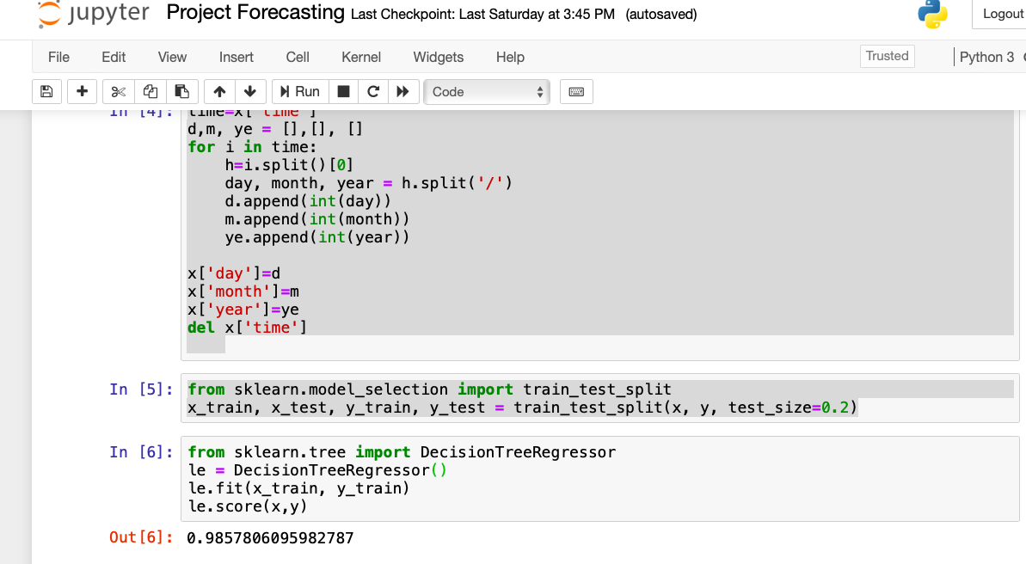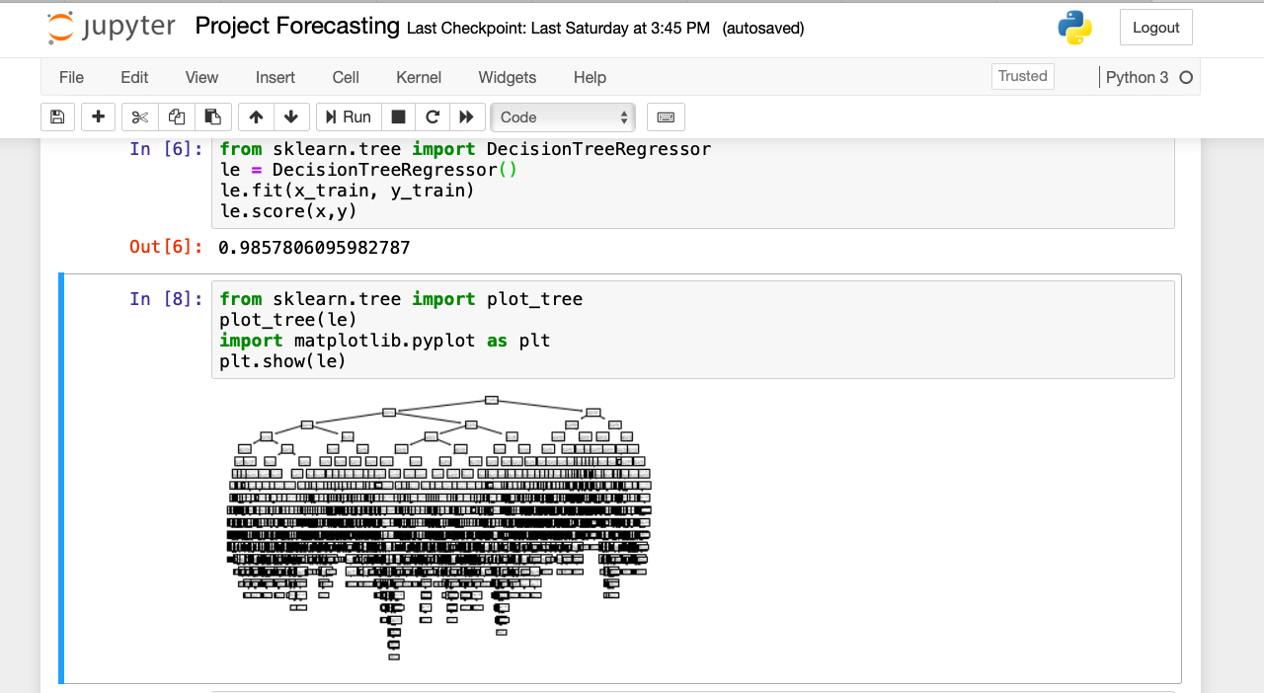

# Result and Discussion

Accurate forecasts that meet the forthcoming consumption demands of customers help retail business owners and management to maximize and extend profits over the long term. Forecasting permits price adjustments to correspond with the current level of consumer spending patterns. Maintaining and controlling a sufficient but moderate inventory that meets the need without being excessive also adds to long-term profits in the retail industry.

# Conclusion

During this article we have developed a predictive model that can help retailers to determine the number of sales that they are going to make in the future.

By using this model, retailers will be able to planify the amount of products that they are going to need and, as a consequence, the system will allow them to increase their profits.

# Future Scope

Sales forecasts allow you to spot potential issues while there's still time to avoid or mitigate them. For example, if you notice your team is trending 35% below quota, you can figure out what's going on and course-correct. Maybe your competitor has started an aggressive new discounting campaign, or your new sales comp plan unintentionally encourages bad behavior.

Discovering these problems now -- versus at the end of the month or quarter -- has a huge impact.

Sales forecasts also come into play for a number of decisions, from hiring and resource management to goal-setting and budgeting.

Suppose your sales forecast predicts a 26% increase in opportunities. To make sure you're keeping up with demand, you should start recruiting. If opportunities are predicted to go down, on the other hand, it would be wise to pause your hiring efforts. Simultaneously, look at bumping up marketing spend and investing in prospecting training for your reps.

In addition, a sales forecast is a powerful motivation tool.

For example, each week you might update your quarterly sales forecast to see if your team is on track to hit its target. You could also create a forecast every day for an individual sales rep on a performance plan to make sure he's not falling behind.

# References

1. <https://smallbusiness.chron.com/explain-forecasting-retail-37966.html>
2. <https://www.stitchlabs.com/learning-center/what-is-demand-forecasting-in-retail/>
3. http://www.bigdatanalysis.com/demand-forecasting-planning-retail/